Magnetic Ressonance Image Processing by Wavelet Transform
Thiago Oliveira dos Santos
Fernando Fernandes Paiva
Physics Institute of Sao Carlos (IFSC) – University of Sao Paulo (USP)
toszerodois@usp.br

Objectives
This project aims to evaluate image processing strategies for Magnetic Resonance Imaging (MRI) using the Wavelet Transform (WT). The goal is to analyze the effectiveness of different wavelet families and thresholding techniques in reducing noise while preserving edges and structural details. The specific objectives include: (i) identifying the most suitable wavelet family for noise suppression; (ii) investigating the effectiveness of hard/soft thresholding techniques; and (iii) relating WT parameters to the final image quality, as measured by the Signal-to-Noise Ratio (SNR).

Materials and Methods
Initially, a theoretical review was carried out on the Discrete Wavelet Transform (DWT) (Guido,

2022) and thresholding techniques (Donoho & Johnstone, 1994; Pereira & Barros, 2025). This study guided the implementation of the pipelines (Menezes, 2017) and the critical analysis of the subsequent results.
A grayscale MRI image (PGM) was used as a test case, processed in Python with NumPy, Matplotlib, and PyWavelets (Harris et al., 2020; Hunter, 2007; Lee et al., 2019).
The image was corrupted with Gaussian noise controlled by a target SNR (7.5–20 dB), and then a 2-level 2D DWT was applied using the Haar, Daubechies-2 (db2), Symlet-2 (sym2), and Coiflet-1 (coif1) families. The universal VisuShrink threshold (λ = σ√(2 log N)) was calculated for the corrupted images, from which both hard and soft thresholding were evaluated.

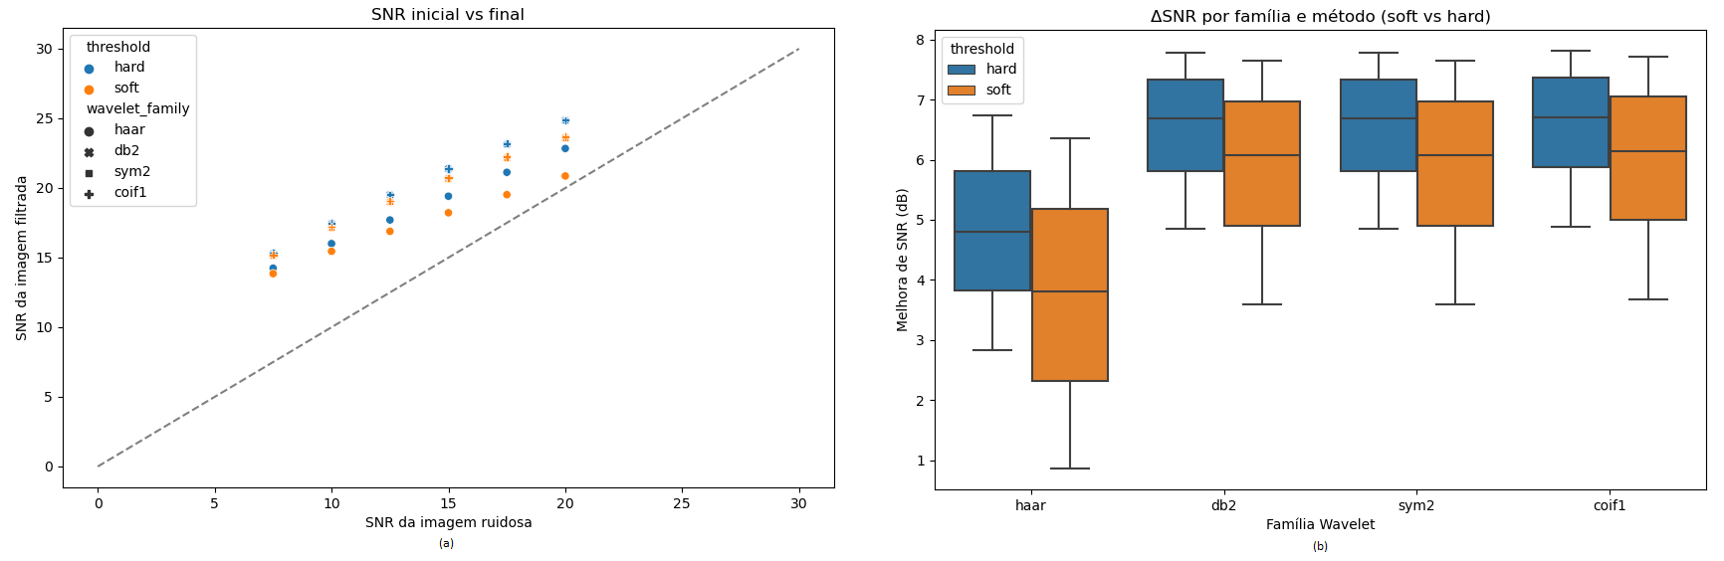

Figure 1: (a) Scatter plot comparing input SNR to output SNR. (b) Boxplot of SNR gain by wavelet family.

After thresholding, the images were reconstructed and compared according to the output SNR, and the results were recorded in a spreadsheet, which was analyzed through a boxplot and a scatter plot.

Results
The generated plots can be seen in Figure 1. They indicate that all wavelet families performed similarly in terms of SNR gain, except for the Haar family. It is also noticeable that hard thresholding was more effective for SNR gain than soft thresholding.
Furthermore, given the slopes of the lines formed by the points in the scatter plot, it is possible to observe that there is a limit in the input SNR beyond which the methods cease to be effective.
Another point analyzed—this time qualitatively—was the fact that signals with lower noise levels (7.5; 10) suffered significant resolution losses, an indicator that thresholding is also affecting the signal coefficients.

Conclusions
The results demonstrate that the 2D Wavelet Transform is an effective tool for noise reduction in MRI images. Hard thresholding proved to be more advantageous, significantly increasing the SNR; however, it is important to highlight that soft thresholding usually does not achieve the same results as hard thresholding, since the coefficients that are not set to zero reduce the final signal intensity, indicating that other quality metrics may be considered. Among the evaluated families, Haar stood out for its poorer performance, which may not be unexpected given its simplicity.
These results reinforce the potential of wavelets in MRI denoising and point to the need to investigate more advanced adaptive methods, such as SureShrink and BayesShrink.
I declare no conflict of interest.
Thiago Oliveira dos Santos conceived the study, implemented the Python codes, conducted the experiments, and analyzed the results.
Fernando Fernandes Paiva supervised the project, contributed to the interpretation of the results, and revised the manuscript.

References
GUIDO, Rodrigo Capobianco. Wavelets behind the scenes: practical aspects, insights, and perspectives. Physics Reports, v. 985, p. 1–23, 2022.
MALLAT, Stéphane. A Wavelet Tour of Signal Processing: The Sparse Way. 3rd ed. Amsterdam: Academic Press/Elsevier, 2008.
MENEZES, Leon Paixão. Development of wavelet-based filters for Magnetic Resonance Spectroscopy. MSc Dissertation — IFSC/USP, São Carlos, 2017.
DONOHO, David L.; JOHNSTONE, Iain M. Ideal spatial adaptation by wavelet shrinkage. Biometrika, v. 81, n. 3, p. 425–455, 1994.
PEREIRA NETO, Ananias; BARROS, Fabrício J. B. Noise reduction in brain magnetic resonance imaging using adaptive wavelet thresholding based on linear prediction factor. Frontiers in Neuroscience, v. 18, art. 1516514, 2025.
HARRIS, Charles R. et al. Array programming with NumPy. Nature, v. 585, p. 357–362, 2020.
HUNTER, John D. Matplotlib: A 2D Graphics Environment. Computing in Science & Engineering, v. 9, n. 3, p. 90–95, 2007.
LEE, Gregory R. et al. PyWavelets: A Python package for wavelet analysis. Journal of Open Source Software, v. 4, n. 36, p. 1237, 2019.

